**Topics: Descriptive Statistics and Probability**

1. Look at the data given below. Plot the data, find the outliers and find out $μ, σ, σ^{2}$

|  |  |
| --- | --- |
| **Name of company** | **Measure X** |
| Allied Signal | 24.23% |
| Bankers Trust | 25.53% |
| General Mills | 25.41% |
| ITT Industries | 24.14% |
| J.P.Morgan & Co. | 29.62% |
| Lehman Brothers | 28.25% |
| Marriott | 25.81% |
| MCI | 24.39% |
| Merrill Lynch | 40.26% |
| Microsoft | 32.95% |
| Morgan Stanley | 91.36% |
| Sun Microsystems | 25.99% |
| Travelers | 39.42% |
| US Airways | 26.71% |
| Warner-Lambert | 35.00% |

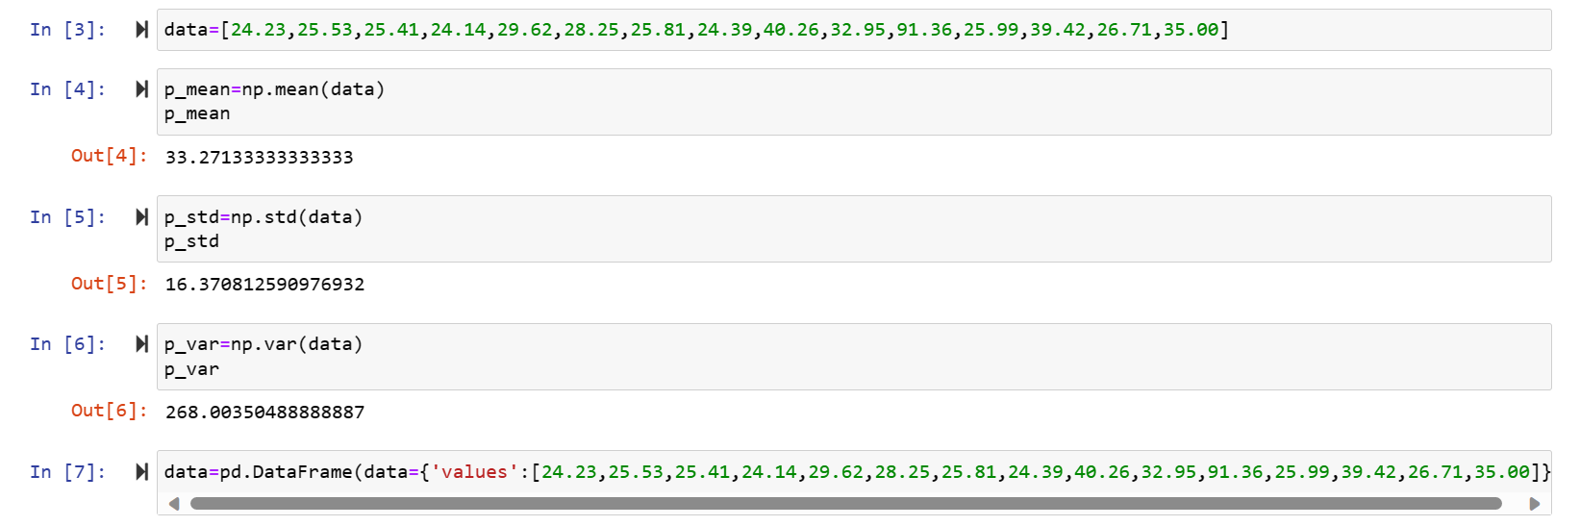

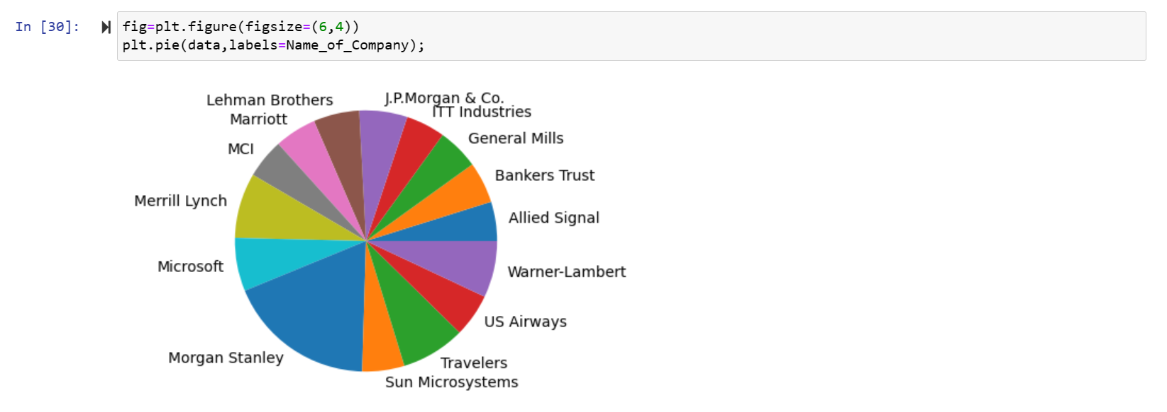

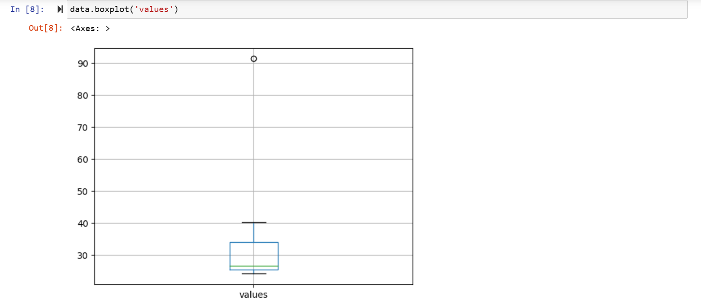



Answer the following three questions based on the box-plot above.

1. What is inter-quartile range of this dataset? (please approximate the numbers) In one line, explain what this value implies.

**Answer:** Inter-quartile range of the dataset is from 5 to 12.5, which implies that Quartile 1 is 5 and Quartile 2 is 12.5 i.e., IQR=12.5-5=7.5

1. What can we say about the skewness of this dataset?

**Answer:** The distribution is positively skewed with right tail.

1. If it was found that the data point with the value 25 is actually 2.5, how would the new box-plot be affected?

**Answer:** The boxplot will not have any outliers and the median value will remain same.

3.



Answer the following three questions based on the histogram above.

1. Where would the mode of this dataset lie?

**Answer:** Mode lies between 4 and 8

1. Comment on the skewness of the dataset.

**Answer:** The data is positively skewed.

1. Suppose that the above histogram and the box-plot in question 2 are plotted for the same dataset. Explain how these graphs complement each other in providing information about any dataset.

**Answer:** Since given that the above histogram and the box-plot in question 2 are plotted for the same dataset then they have the same nature of distribution. In histogram most of the data points lie between 2 to 16 so graph is positively skewed.

4. AT&T was running commercials in 1990 aimed at luring back customers who had switched to one of the other long-distance phone service providers. One such commercial shows a businessman trying to reach Phoenix and mistakenly getting Fiji, where a half-naked native on a beach responds incomprehensibly in Polynesian. When asked about this advertisement, AT&T admitted that the portrayed incident did not actually take place but added that this was an enactment of something that “could happen.” Suppose that one in 200 long-distance telephone calls is misdirected. What is the probability that at least one in five attempted telephone calls reaches the wrong number? (Assume independence of attempts.)

**Answer:** The probability that a single attempted call is not misdirected is 1 - (1/200) because one in 200 calls is misdirected.

Since the attempts are independent, the probability that all five attempted calls are not misdirected is (1 - 1/200)**5**.

Now, we subtract this probability from 1 to find the probability that at least one in five calls is misdirected: 1 - (1 - 1/200)**5** ≈ 0.0244

Therefore, the probability that at least one in five attempted telephone calls reaches the wrong number is approximately 0.0244 or 2.44%.

5.Returns on a certain business venture, to the nearest $1,000, are known to follow the following probability distribution

|  |  |
| --- | --- |
| x | P(x) |
| -2,000 | 0.1 |
| -1,000 | 0.1 |
| 0 | 0.2 |
| 1000 | 0.2 |
| 2000 | 0.3 |
| 3000 | 0.1 |

(i) What is the most likely monetary outcome of the business venture?

(ii) Is the venture likely to be successful? Explain

(iii) What is the long-term average earning of business ventures of this kind? Explain

(iv) What is the good measure of the risk involved in a venture of this kind? Compute this measure

|  |  |  |  |
| --- | --- | --- | --- |
| **X** | **P(X)** | **E(X)=X.P(X)** | $${E(X}^{2})=X^{2}.P(X)$$ |
| -2000 | 0.1 | -200 | 400000 |
| -1000 | 0.1 | -100 | 100000 |
| 0 | 0.2 | 0 | 0 |
| 1000 | 0.2 | 200 | 200000 |
| 2000 | 0.3 | 600 | 1200000 |
| 3000 | 0.1 | 300 | 900000 |
|  | 1 | 800 | 2800000 |

**Answers:**

**(i)** The most likely monetary outcome of the business venture is 2000 since it has has the maximum probability 0.3.

**(ii)** The venture likely to be successful is X is positive, hence if X is 1000,2000,3000 then

Probability = 0.2+0.3+0.1 = 0.6

Since 0.6>0.5, Therefore venture is likely to be 60% successful.

**(iii)** Long term average earning of business ventures = E(X)

E(X) = ∑ X.P(X)

= 800

Therefore, E(X)=800

**(iv)** P(loss) = P(x=-2000)+P(x=-1000) = 0.1+0.1 = 0.2, So the risk associated with the venture is 20%.